**1. INTENT:** The purpose of this bylaw addition is to establish a method for members of the Monument Professional Firefighters and citizens to be recognized for exceptional performance, contributions to the Local, and various achievements in our local community.

**2. DEFINITIONS:**

Letter of Commendation: A letter sent from the President of the Local at his own initiative or upon recommendation of members of the Local to citizens, organizations, or other agencies for services rendered to the Local.

Appreciation Awards: A formal acknowledgement of a member’s action (on or off duty) that reflects favorably towards the Local, the individual, and/or the community.

“Greener Pasture” Awards: Retirement awards are given to members separating from the District (while in good standing) in recognition of (3) three or more complete years of service.

Service Awards: Service awards acknowledge members that serve as an E-board member for a term of (2) two years.

Medical Retirement: Medical retirement awards are given to members separating from the District due to a medical condition (while in good standing) in recognition of (5) five or more complete years of service.

Full Retirement: Full retirement awards are given to members separating from the District and retiring from their career (while in good standing) in recognition of (10) ten or more complete years of service.

**3. PROCEDURE**:

It is the responsibility of all members to forward any account worthy of recognition by the Local. Typically, these nominations include, but are not limited to: meritorious acts, exceptional forms of customer service, and the achievement of advanced certifications. Recommendations for all levels of recognition shall be submitted in writing on the Locals Achievement and Commendation Nomination Form (Attachment B) to a member of the E-board. The E-board will then evaluate any nominations and investigate/validate their occurrence. The action(s) will then be applied to the award criteria as submitted. The committee has the ability to reclassify the level of the award (higher or lower) based on their findings and interpretations of the circumstance. All internal awards and Civilian awards will be presented at the following scheduled Union meeting. Retirement awards (retirement, service, merit, and peer) are specifically recognized at the Locals farewell ceremony.

**3.1. Retirement Awards**  
Retirement awards are given to members separating from the Local (while in good standing) in recognition of three or more complete years of service. Years of service are the number of full years calculated from service date to separation date. Example: if a member started in August 2000 and retired in February 2005, they would be recognized for (4) four years of service. Retirement Awards are given to members that become members of another Fire Department after three years, medically retire after 5 years, or fully retire after ten years.

3.1.1. Three +Years (“Green Pasture”)

14" x 14" Walnut Maltese Cross Plaque award- $160

<http://www.fireawards.com/maltese-cross-shield-plaque.html>

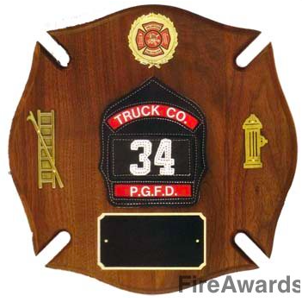

3.1.2 Medical Retirement 5+ Years

Bronze Leather Helmet- $300

<http://www.fireawards.com/brfiheaw.html>

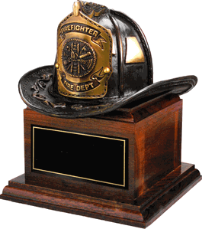

3.1.4. Full Retirement 10+ Years

42"x16"x3/4" walnut plaque w full size chrome plated 36" axe- $500

<http://www.firefighteraxeawards.com/viewFirefighterAxeAwardsProduct.php?firefighterAxeAwardsProductID=297>

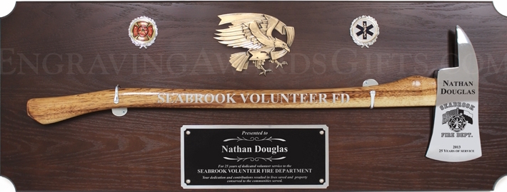

**3.3. Letter of Commendation**

These awards are intended to recognize significant contributions to the membership, often done “behind the scenes.” The criteria is variable but the typical focus is a member who has done exceptional work for the membership and/or our citizens, particularly in meeting a specific need or focus for the year.

3.3.1 <http://www.fireawards.com/10x13cesl.html>

Cherry finish 10.5" x 13" certificate plaque-$20

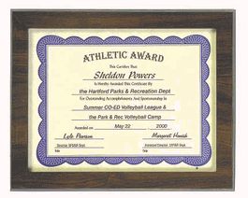Certificates/PDF/4319%20Award%20Magnum.pdf

**3.4. Appreciation Awards**

The recipients of this award may be initiated by the President or by any member of the Local that identify a member that should obtain this award. The process is as follows:

* Nomination forms are made available to all members throughout the year.
* Completed nominations shall be turned in to a member of the E-board at anytime throughout the year.
* Qualifications, if any, for specific awards will be indicated on the form. Any Member may nominate.
* Each nomination must include the name of the nominee, a brief written explanation of why the individual is being nominated, and the name of the nominator.
* <http://www.iaffonlinestore.com/mm5/merchant.mvc?Store_Code=IAFF&Screen=PROD&Product_Code=F945>
* $26



**3.5. Service Awards**

The recipients of this award recognize the value and appreciation of E-board members time and commitment for their service to the Membership.

* Service awards will begin to be awarded after the December 2017 E-board elections. Awards will be given in January each year following December election results.
* <http://eagle-engraving.com/iaff-shield-plaque>
* $125

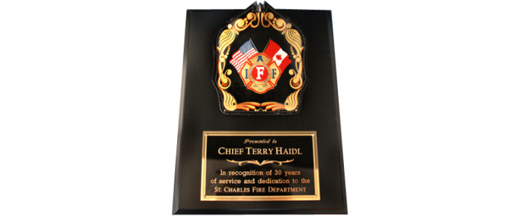

**ATTACHMENTS:** A

1. Nomination Form

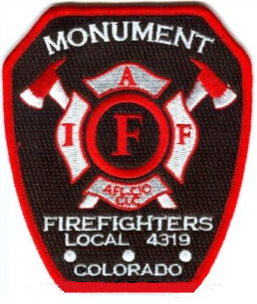Monument Professional Firefighters  
Merit Award Nomination Form

Date______________

Name of Nominee(s)_____________________________________________________

Award Recommended____________________________________________________

Incident number (if applicable)________________

Date of Act_____________

Description of events that qualify individual for award. Be specific and detailed.   
________________________________________________________________________________________________________________________________________________________________________________________________________________________________________________________________________________________________________________________________________________________________________________________________________________________________________________________________________________________________________________________________________________________________________________

(attach additional sheets as necessary or supporting documentation)

Names of witnesses (if applicable) __________________________________________

Name of person submitting nomination_______________________________________  
  
 **__________________________________________________________________________________________________________________________________________________________________________________________________________________________________________  
 __________________________________________________________________________________________________________________________________________________________________________________________________________________________________________**

(E-board use only)

Review conclusions _______________________________________________________________________________________________________________________________________________________________________________________________________________________________________________________________________________________________________________________________________________________________________________________________________________________­­­­­_____________

Award affirmed: yes no Alternate award recommended__________________

E-board members ________________,_______________,_______________

________________,_______________,

Date_________________

Attachment A